MONIQUE NICOLE LECLAIR
Height: 5’8’’ Weight: 125lb Bust: 34D Waist: 24 Hips:36 Shoe: 8 Dress: 4
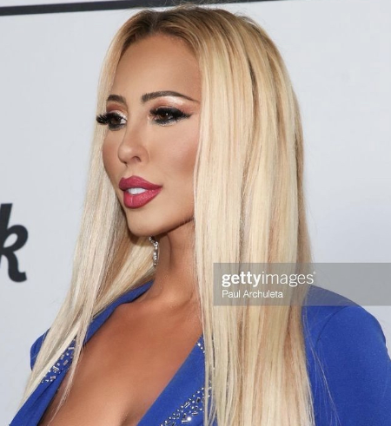
moniqueleclair1@gmail.com (737) 781- 3189 IG: @moniquenicoleleclair www.moniqueleclair.com
TRAINING
Sitcom Acting Technique - Tony Rago - SSAS
Comedy Intensive - Scott Sedita - Scott Sedita Acting Studio
On-Camera Cold Reading - Deborah Quale - SSAS
Nuts & Bolts - Patrick Munoz - Scott Sedita Acting Studio
TELEVISION AND COMMERCIAL
Series Regular- Caught 2: The Series- Mike Merrill
Recurring- WOWE Women of Wrestling - MGM Studios
Le Mans Series Personal Interview - Self - Speed Channel Technical Interface Commercial - ”Nurse” - FHF Marketing
Red Carpet Host - NAACP Theater Awards - TwelveTen360 Personal Interview - Tony Tarantino - TwelveTen360
THEATER
Katherine- The Taming of the Shrew - SNL Productions
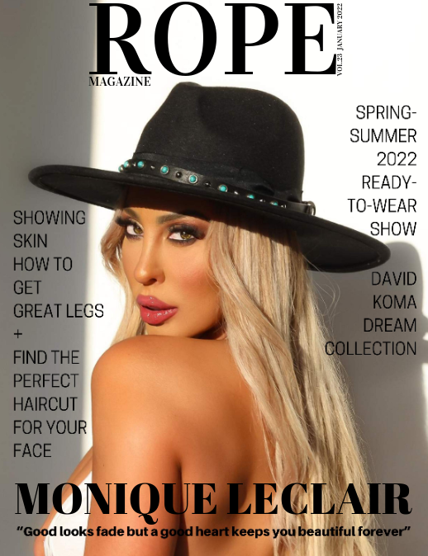
Sarah - Silent Serenity - Berubians Theater Company Wonder Women - Villain “Mistress” - Next Stage Theater
VIDEO
“Sueltame” Music Video- Lawyer’s Wife- Christina Augilera
“Ready for Love” Music Video - Manicurist- Wiz Khalifa feat. Girl Talk
"Any Climate" Music Video - Model - Cormac Feat. Windbreeze
“Jaded” Music Video- Nurse- Cody Jasper

MODELING
Cover - Rope Magazine January 2022
Cover - TwelveTen Magazine - TwelveTen360
Promo - LeMan’s Series - Fastlane Promotions
Catalog Print - Fashion Model - Sears
Fashion - Estorica Clothing
Featured - Fuse Magazine

SPECIAL SKILLS and PROFESSIONS
Stuntwoman, ER/Trauma Nurse, Amateur Wrestling, Professional Wrestling, Jiu-Jitsu, Surfing, Abstract Artist, Painter, Western/English Equestrian, Billiards, Bartending, Street Racing, Offroading/Manual, Skateboarding, Tennis, Rollerblading, Dance (Jazz, Modern, Hip-Hop, Ballet) Languages/Dialects (French, Spanish, Southern, Australian, British)

